C Programming

Platform Coding Practice Question Bank

Module 1 — Input/output, variables and basic arithmetic
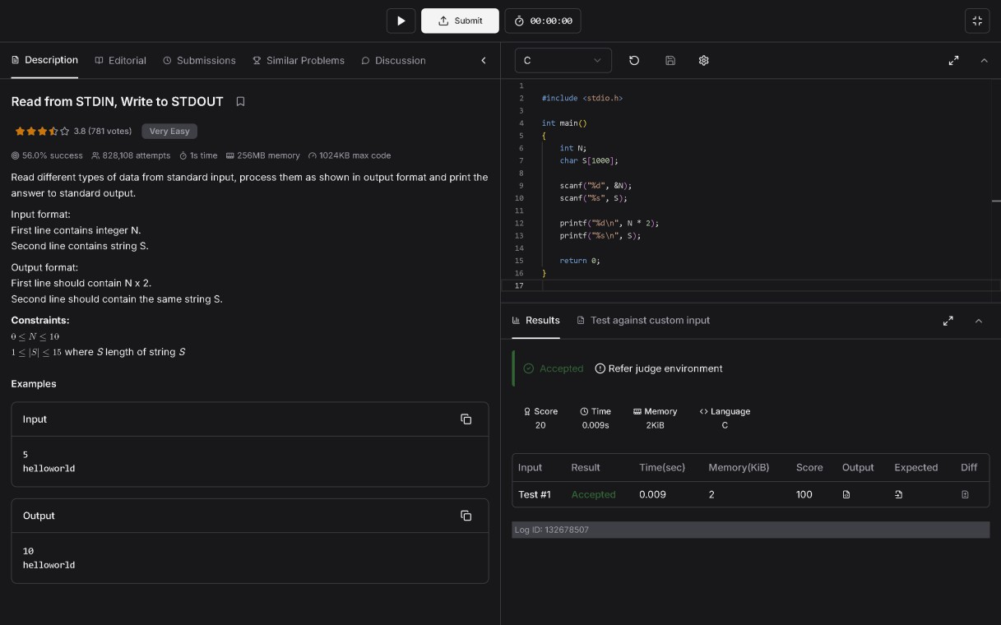
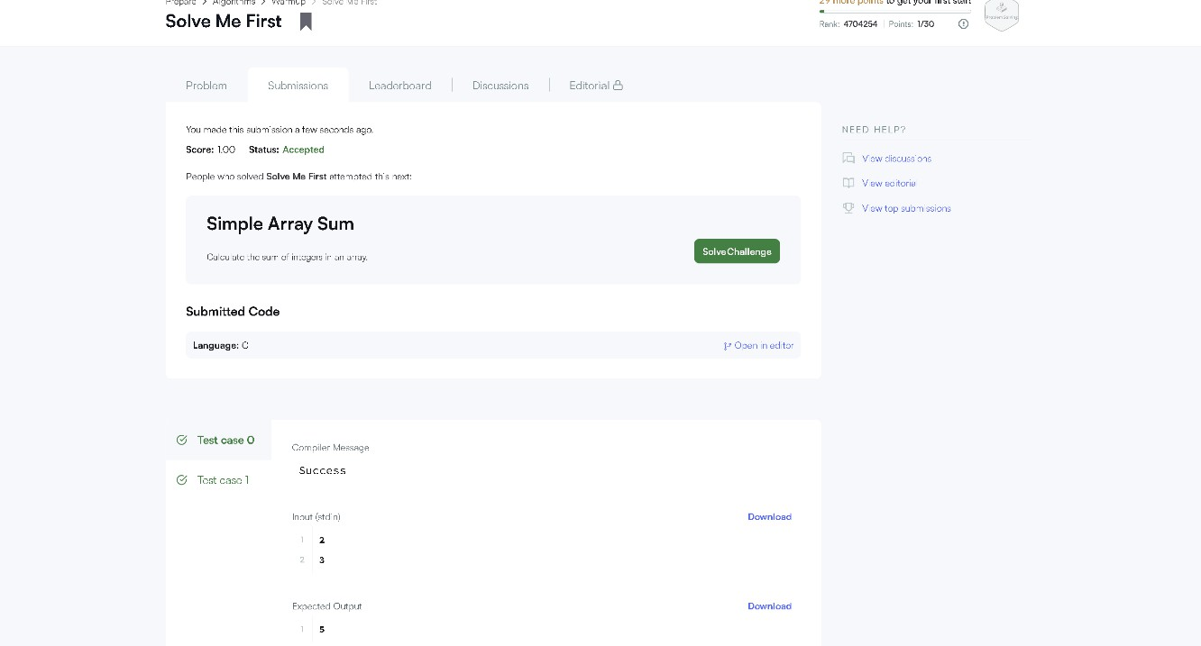

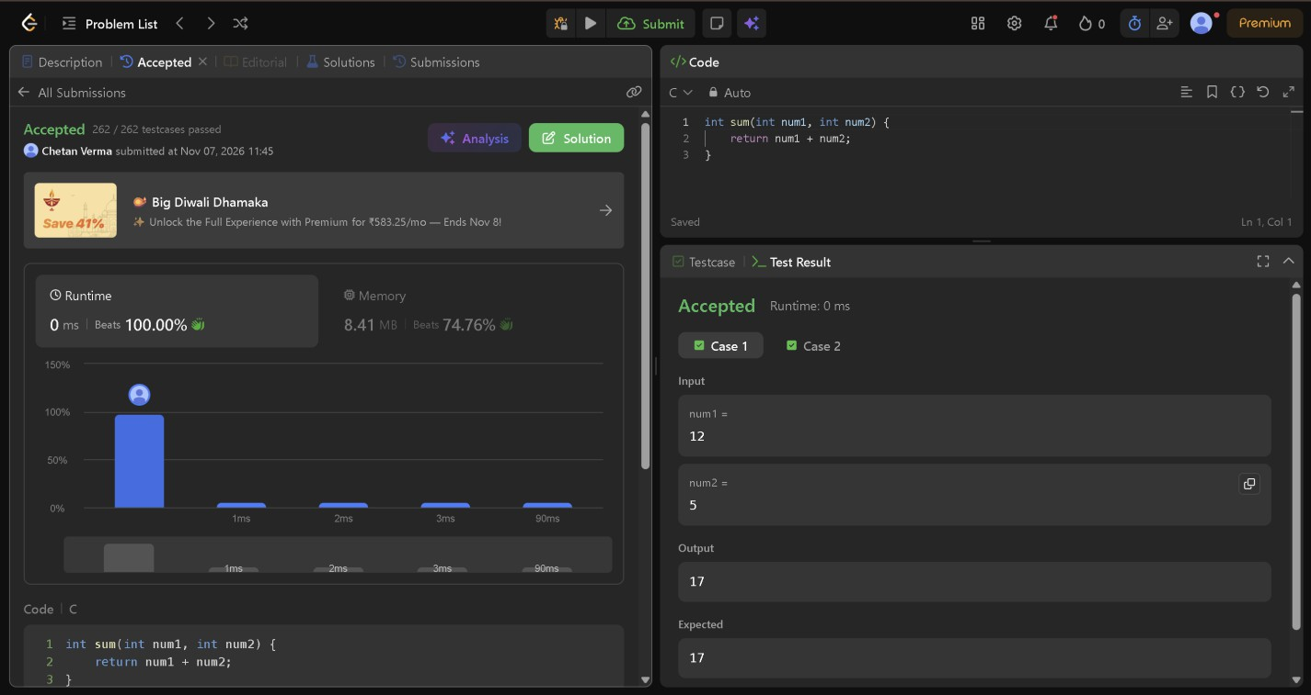
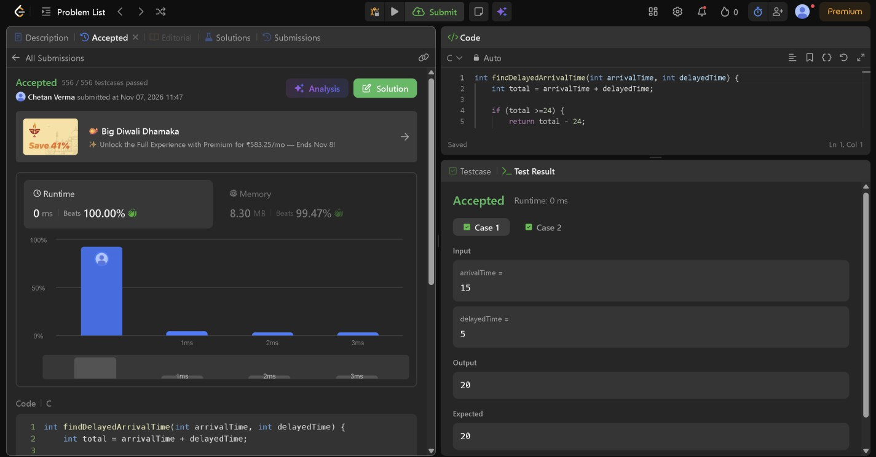

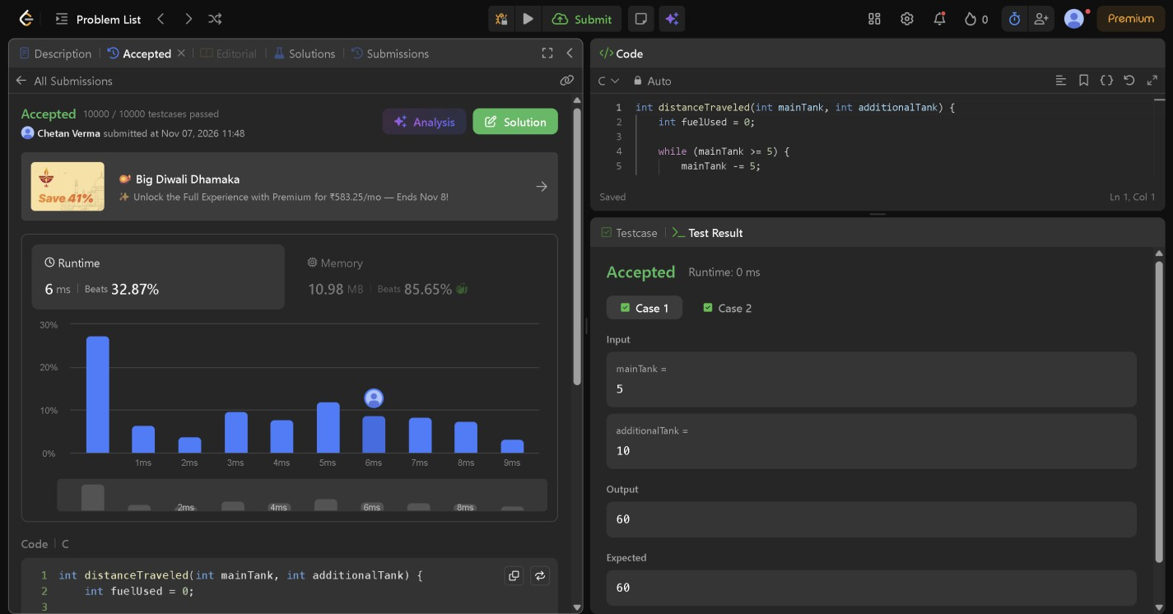

Module 2 — Conditional statements and operators
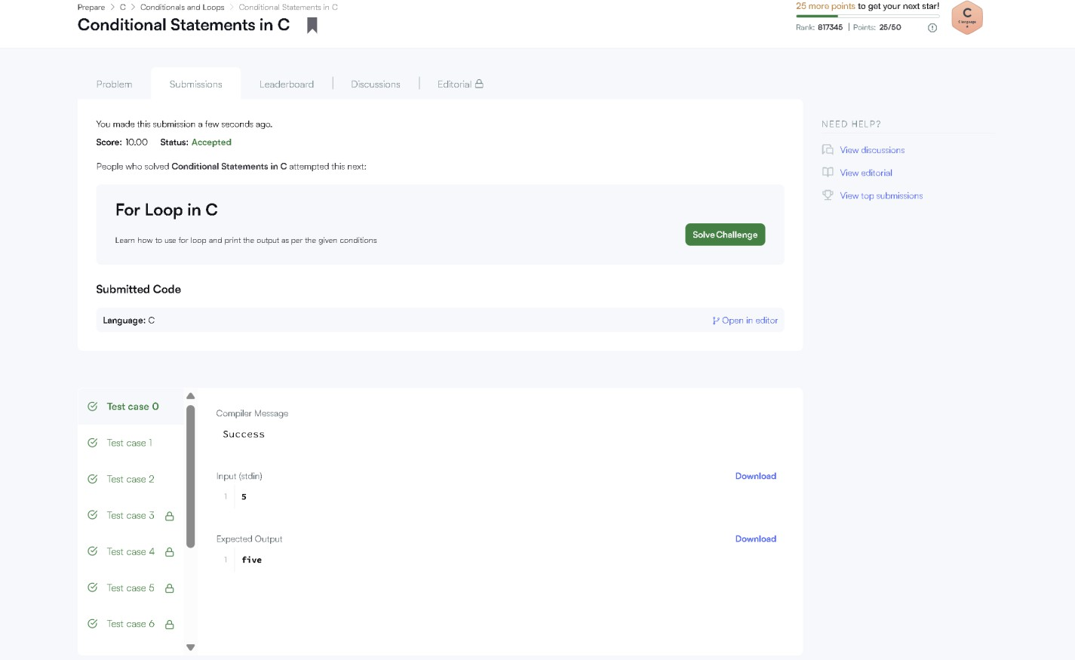

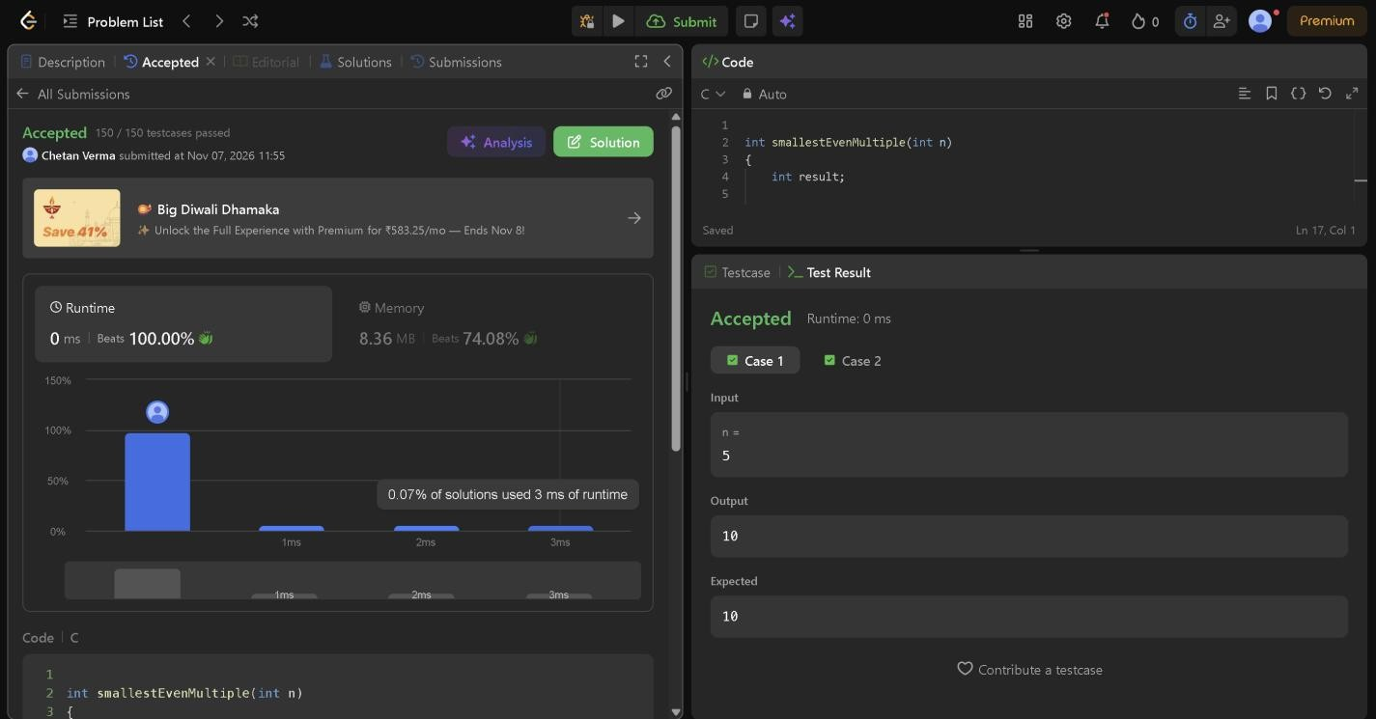
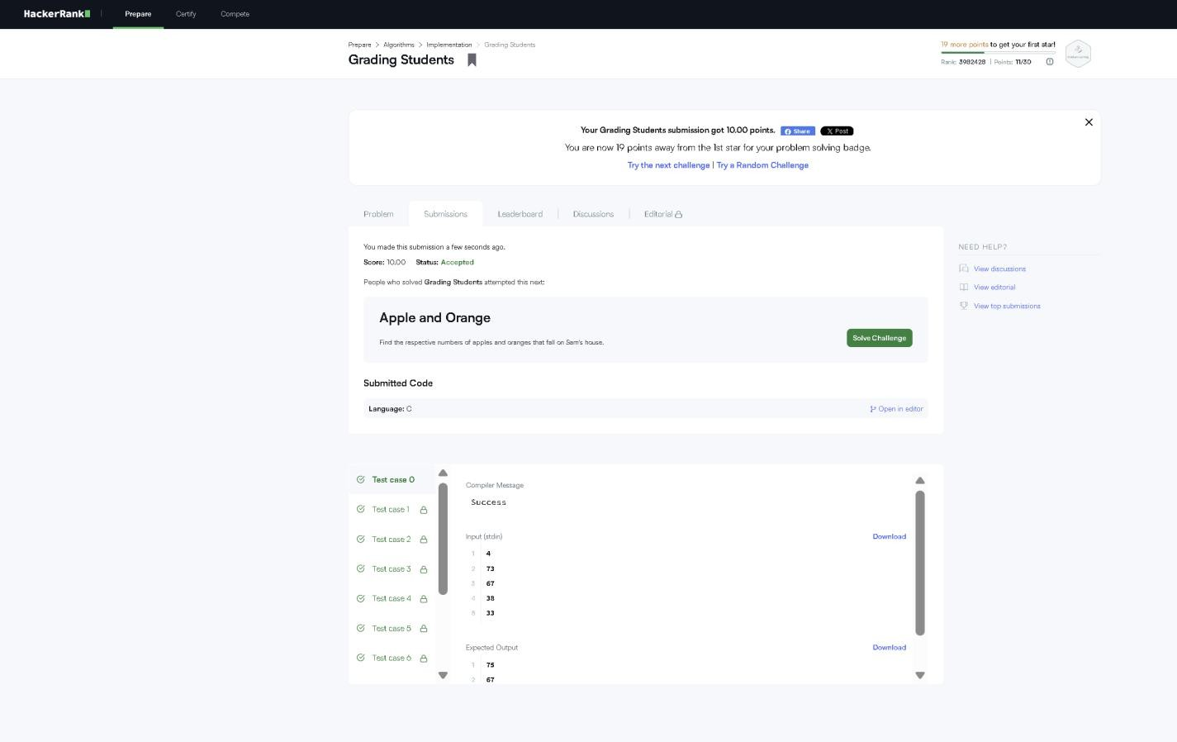

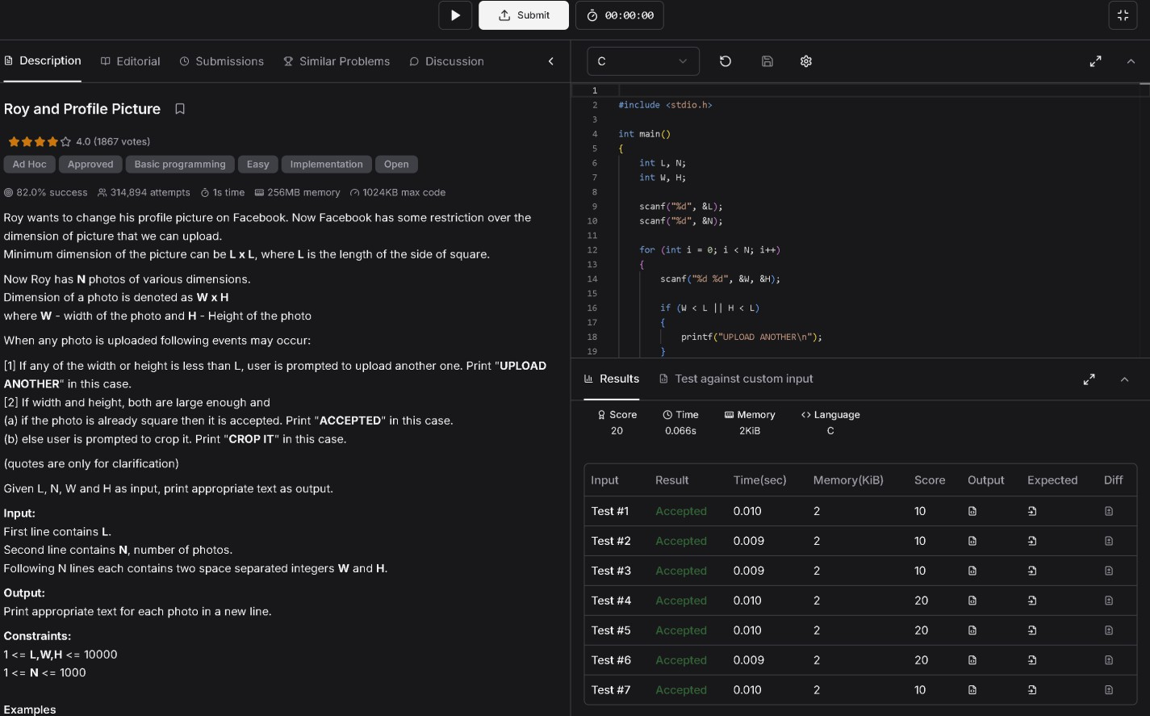
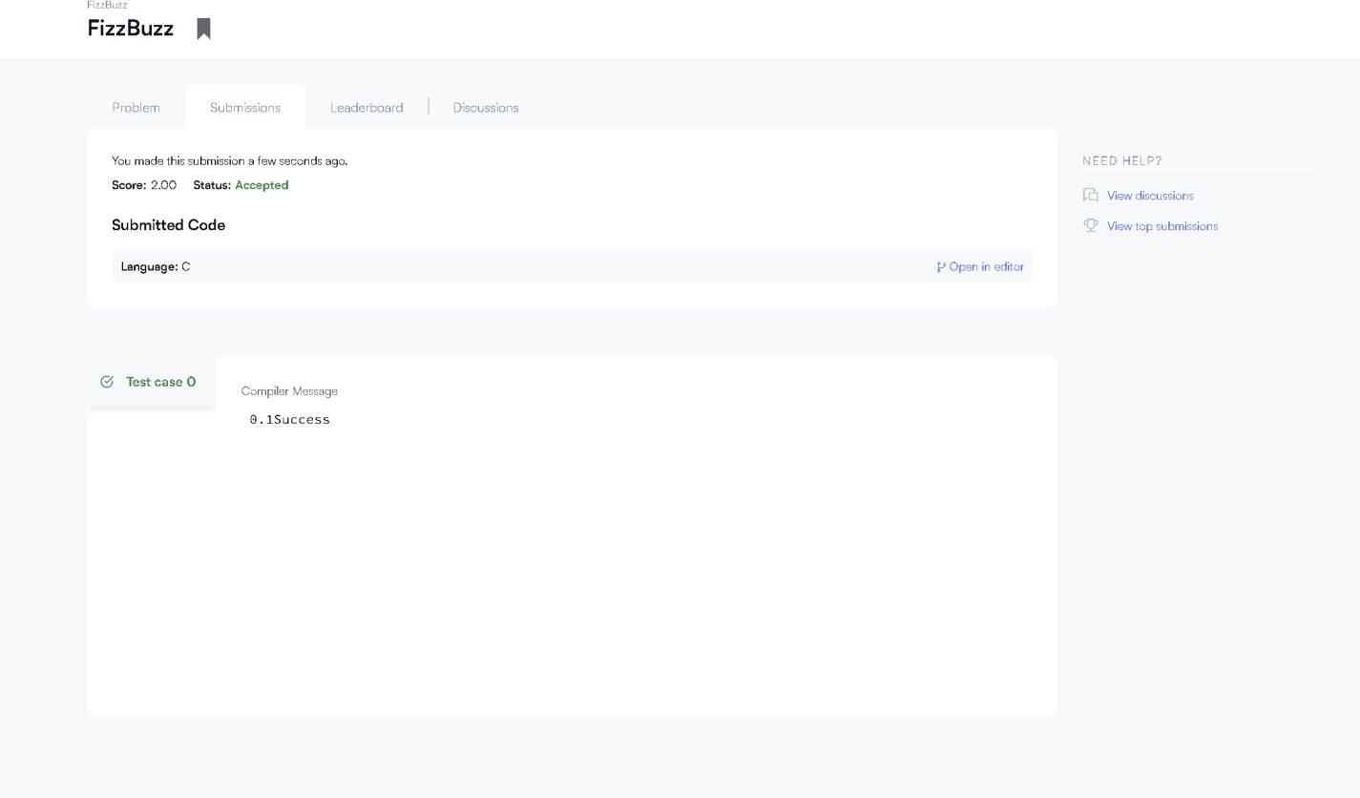

Module 3 — Loops and repeated computation
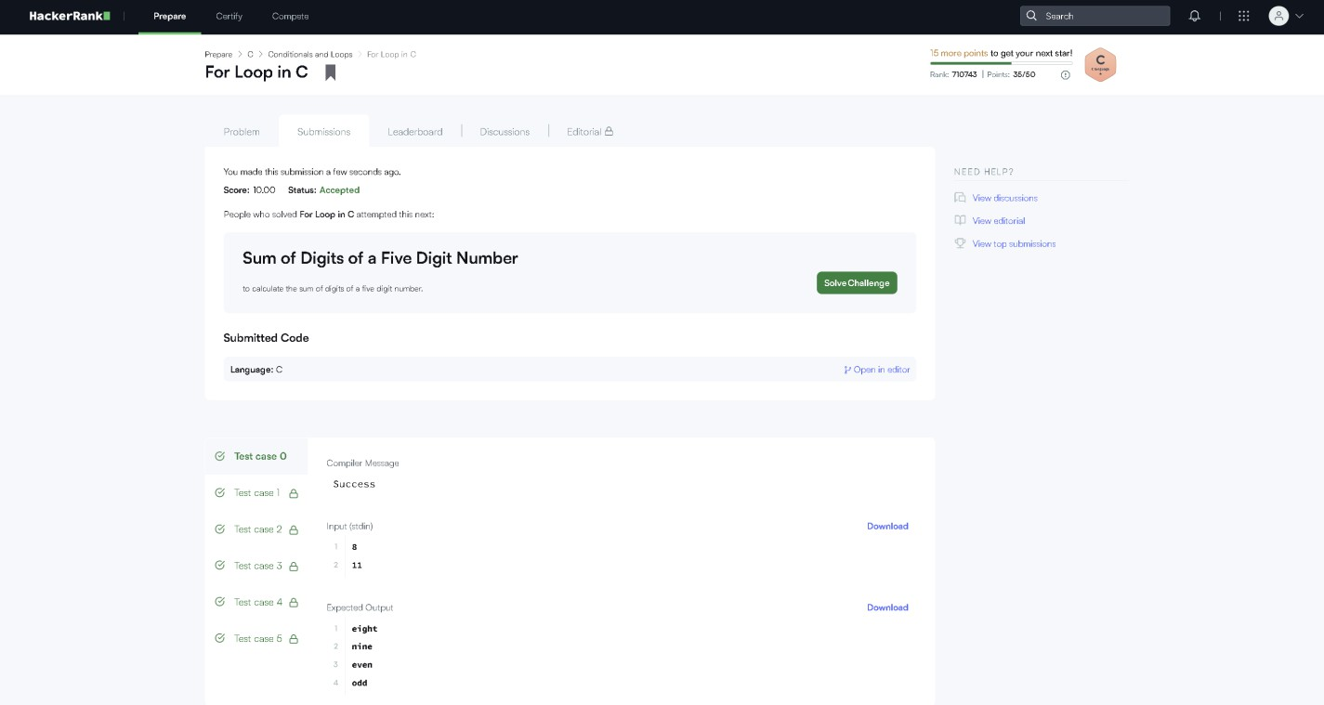

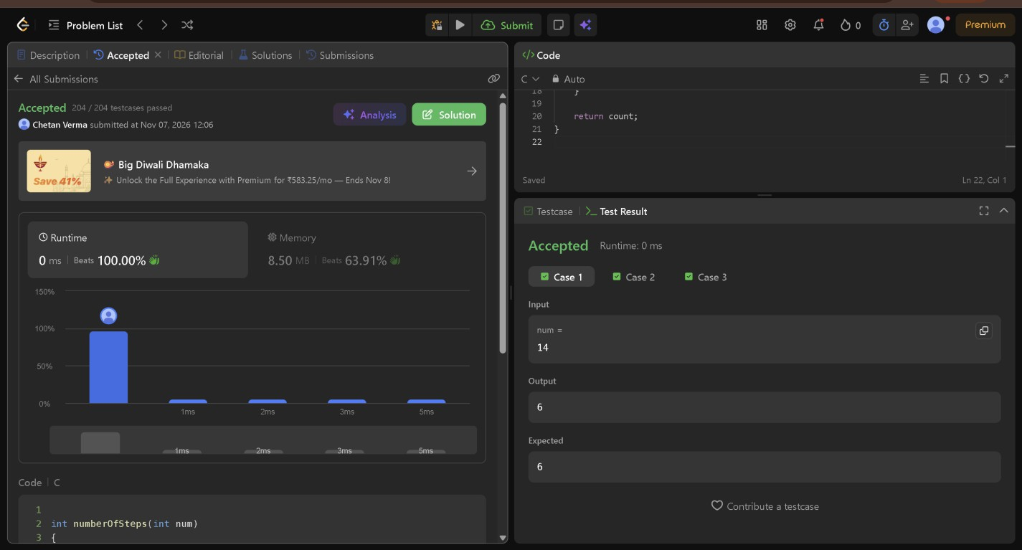

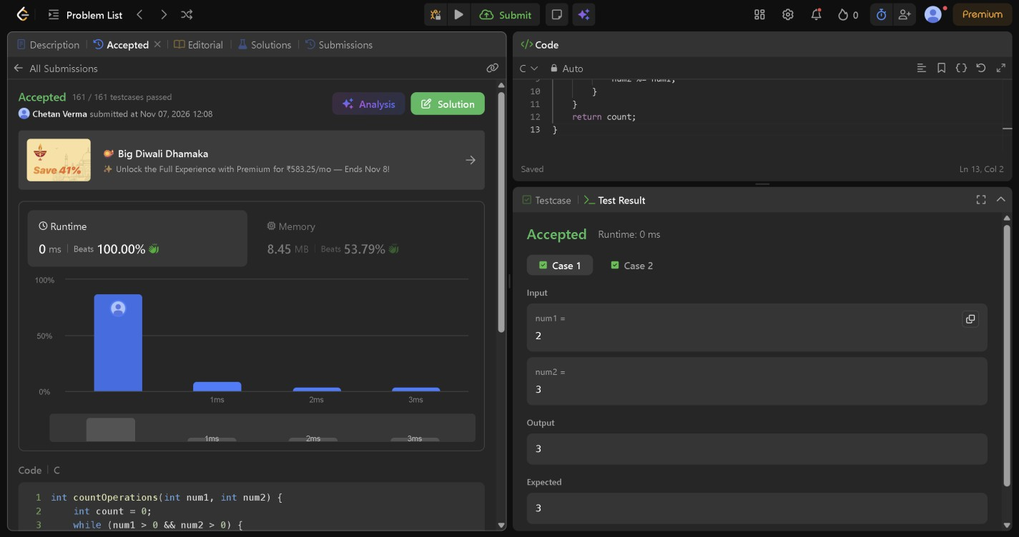
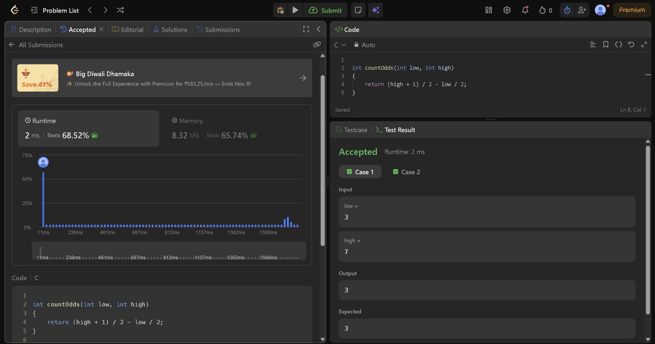

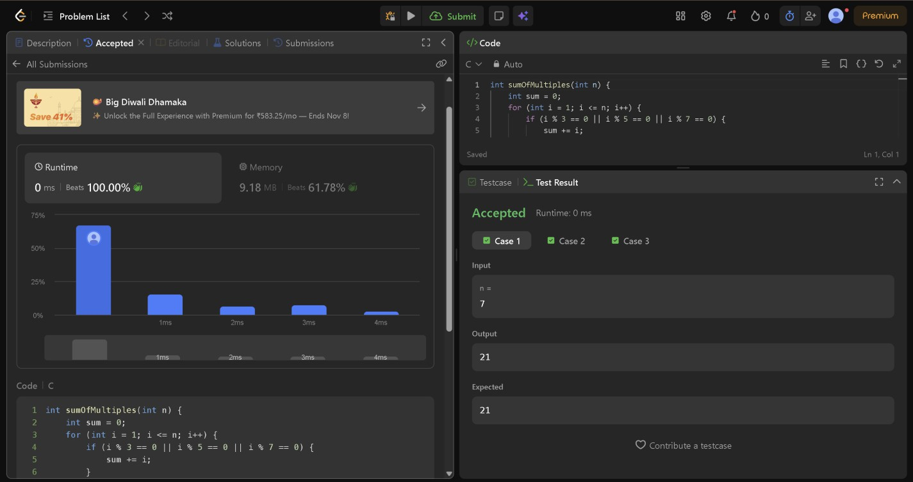
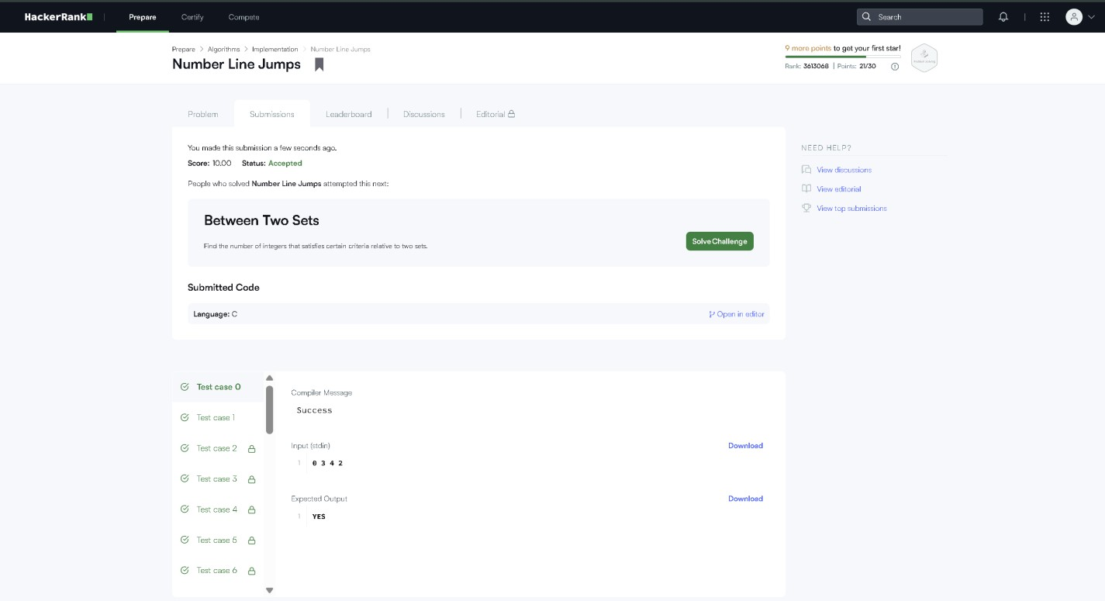

Module 4 — Digit extraction and number manipulation
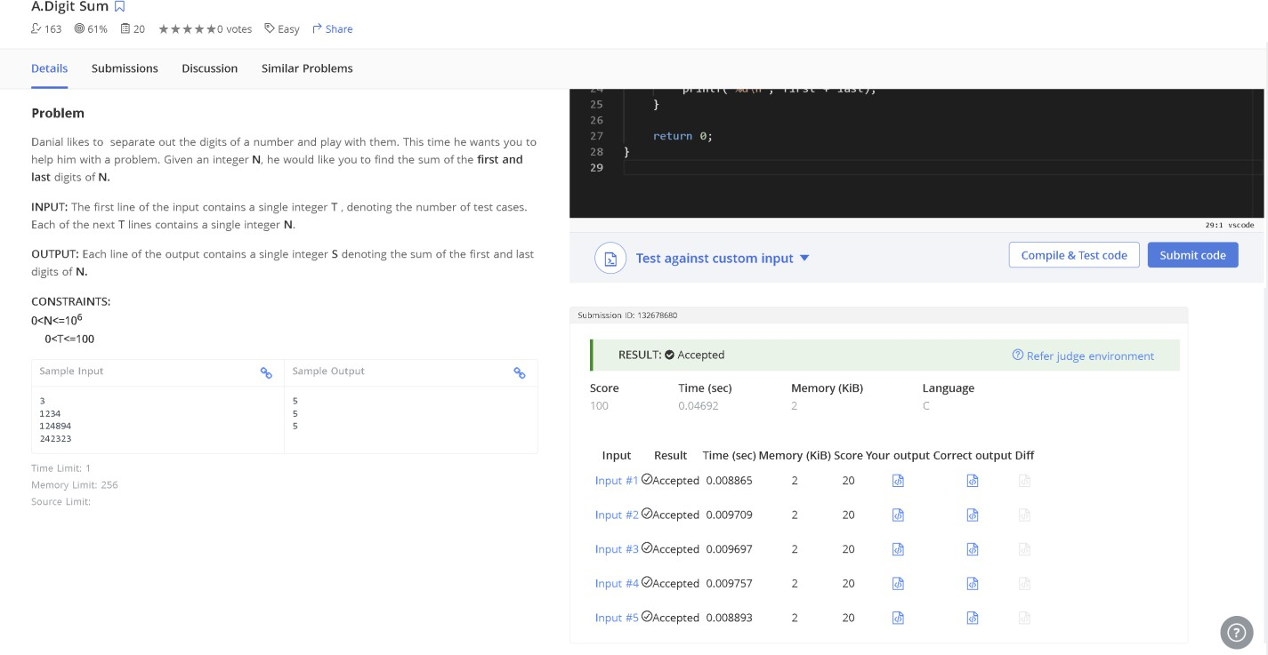

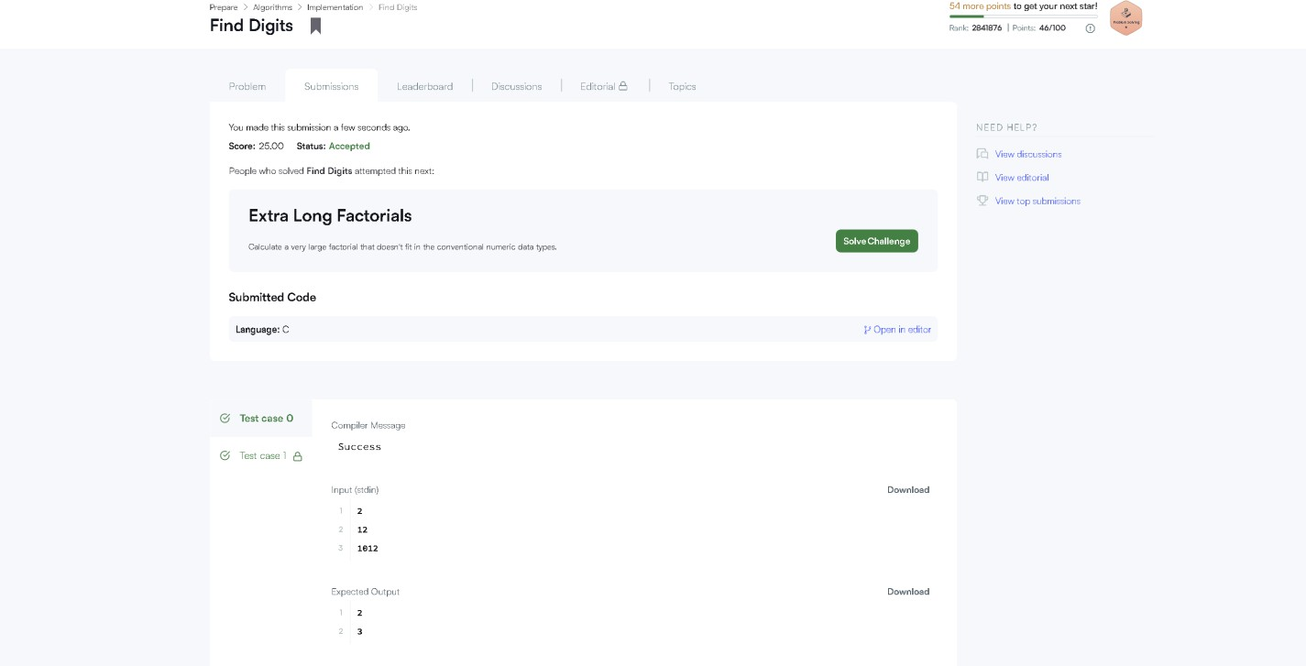

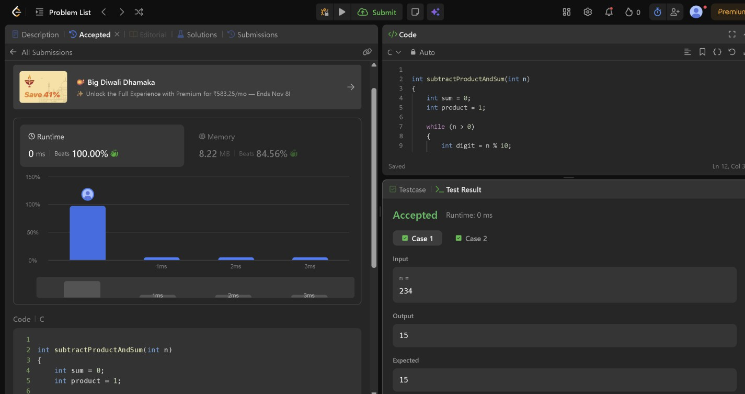
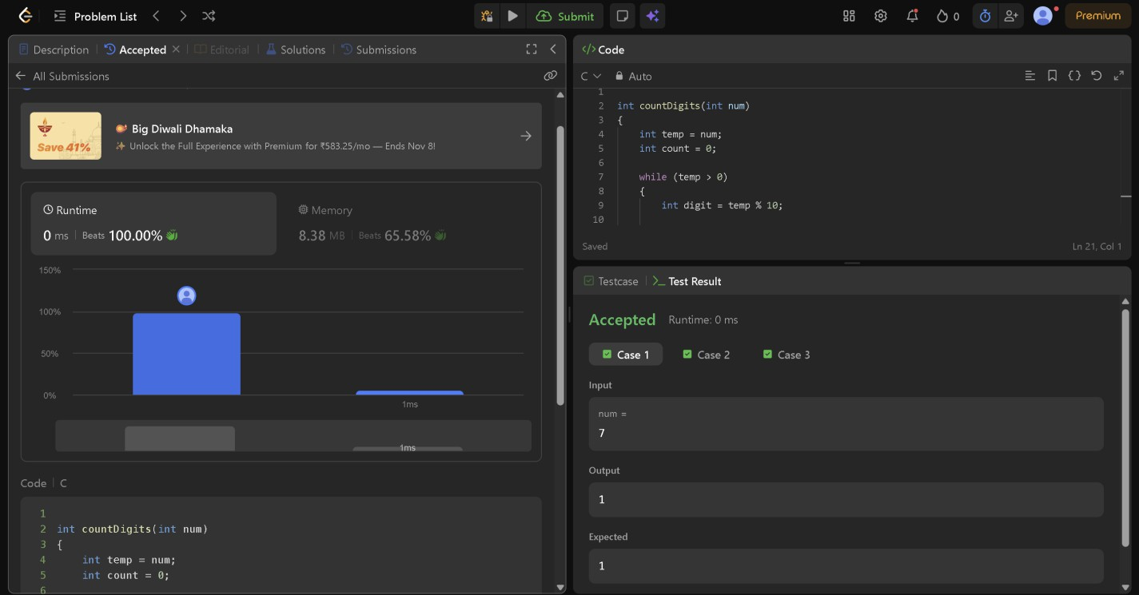

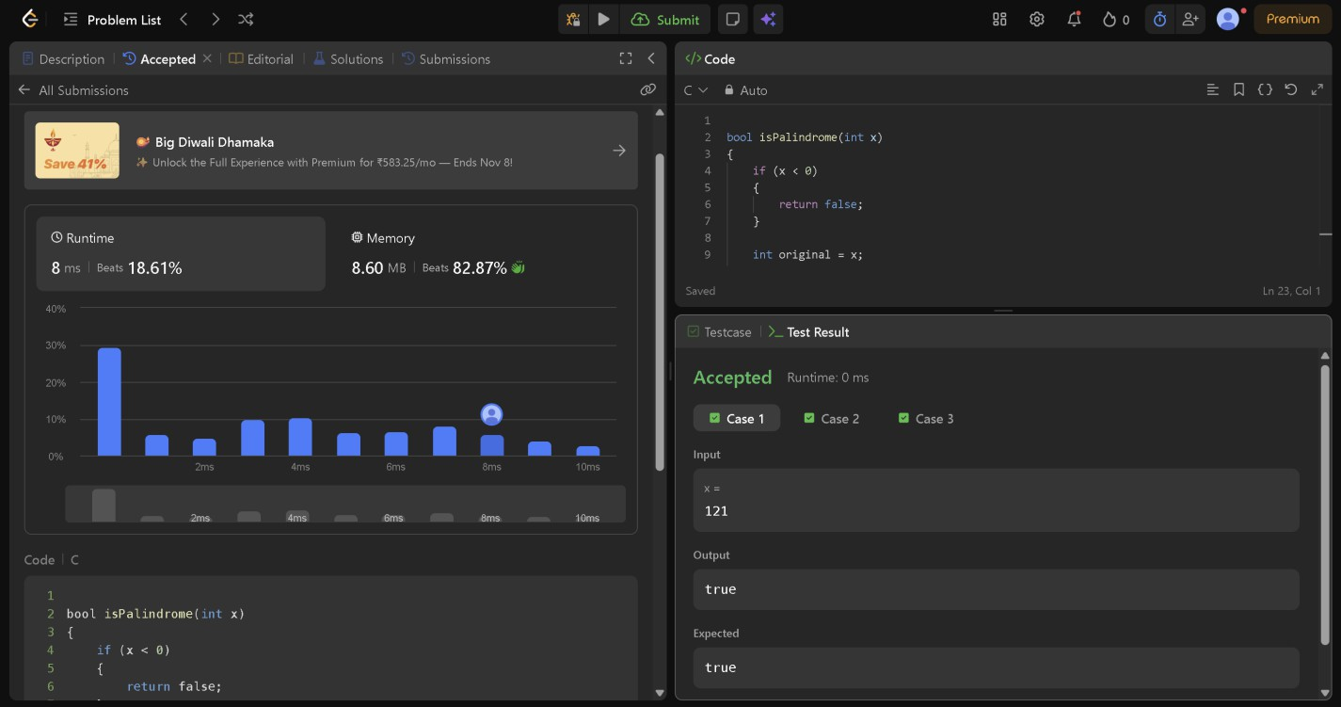

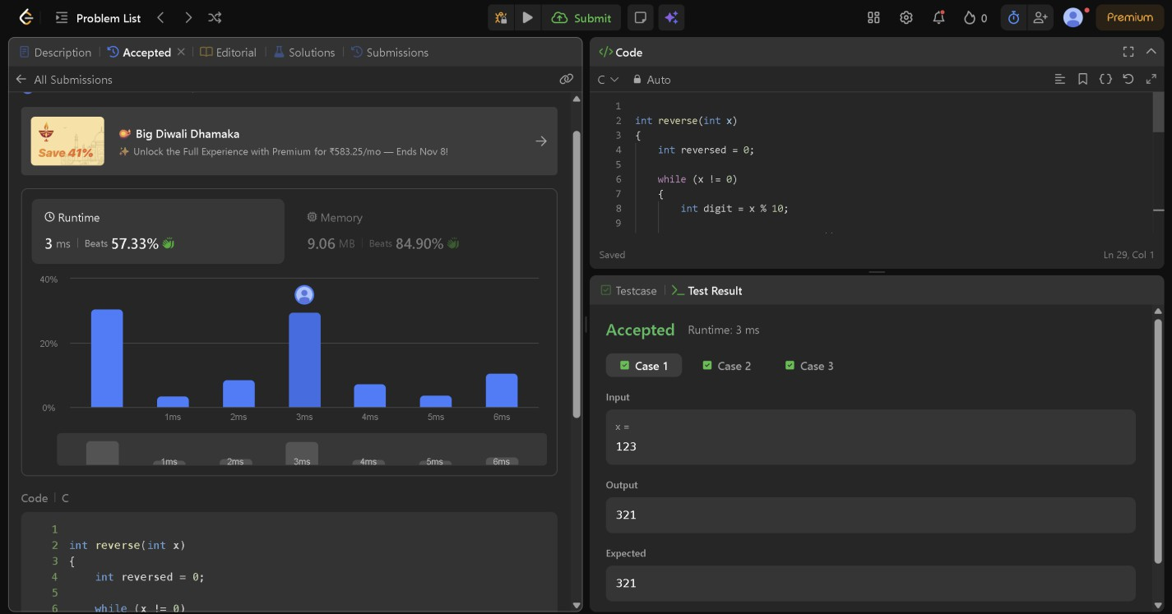

Module 5 — Factors, divisibility and mathematical loops
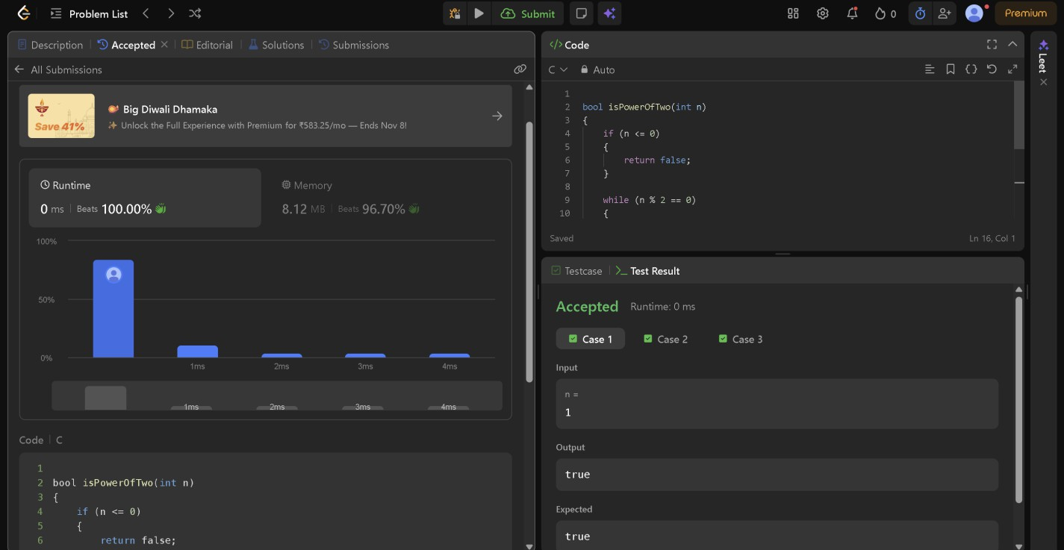
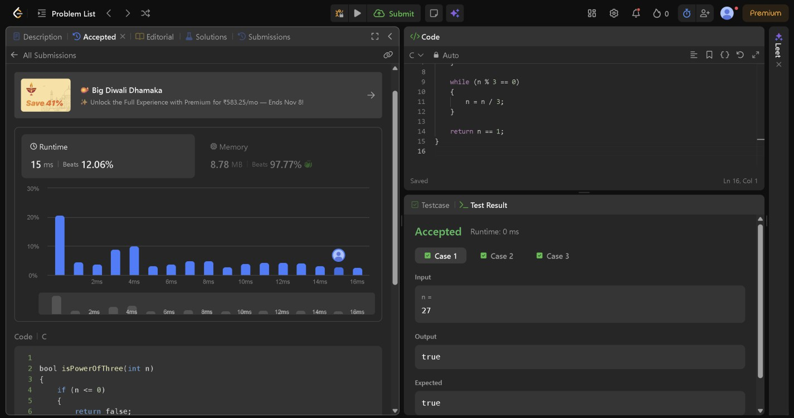

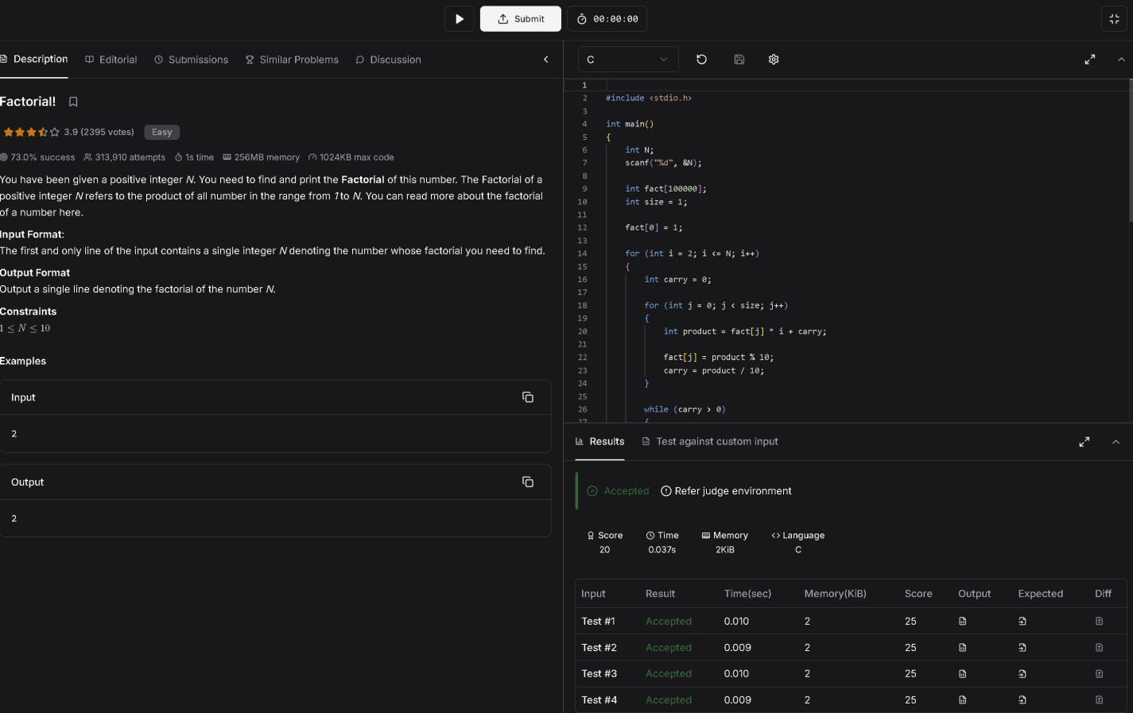
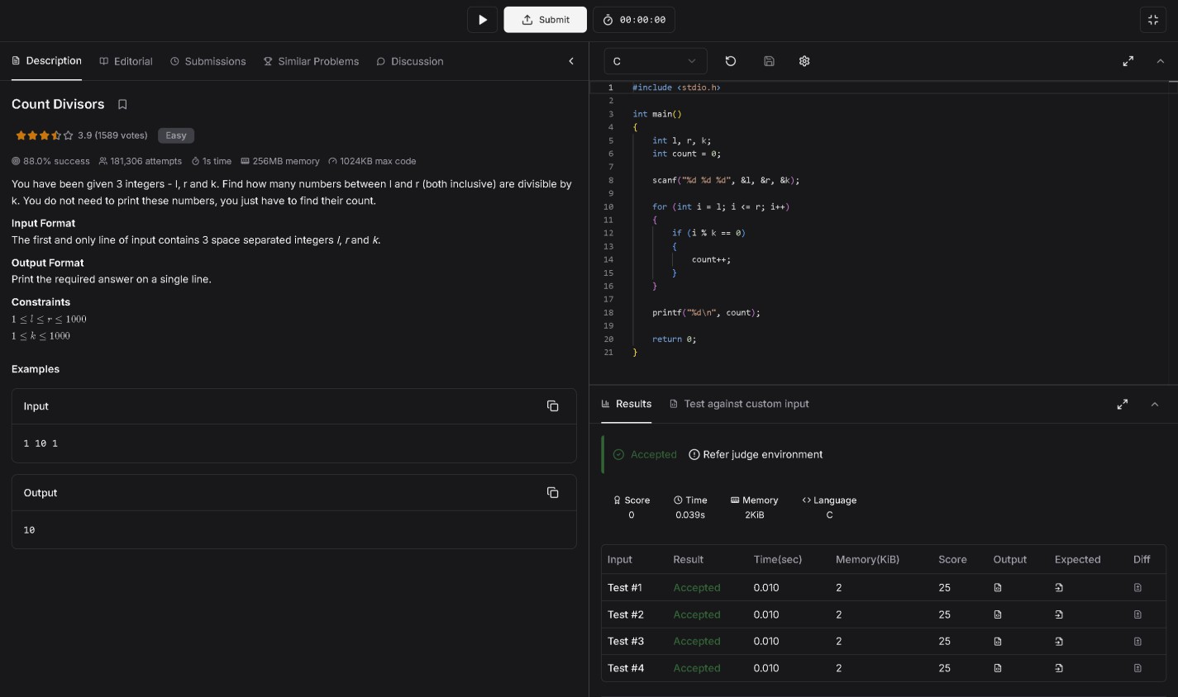

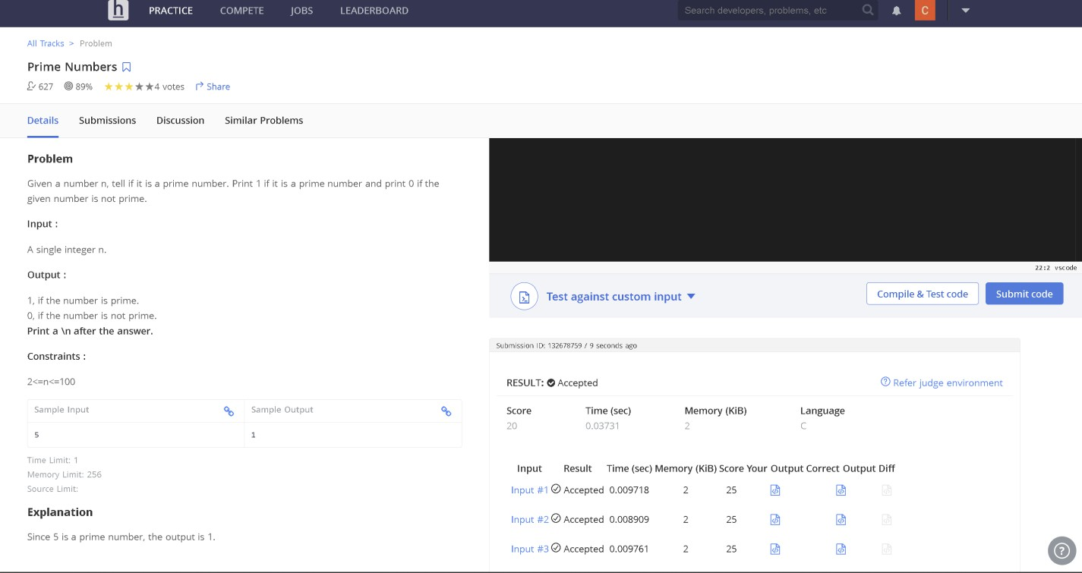

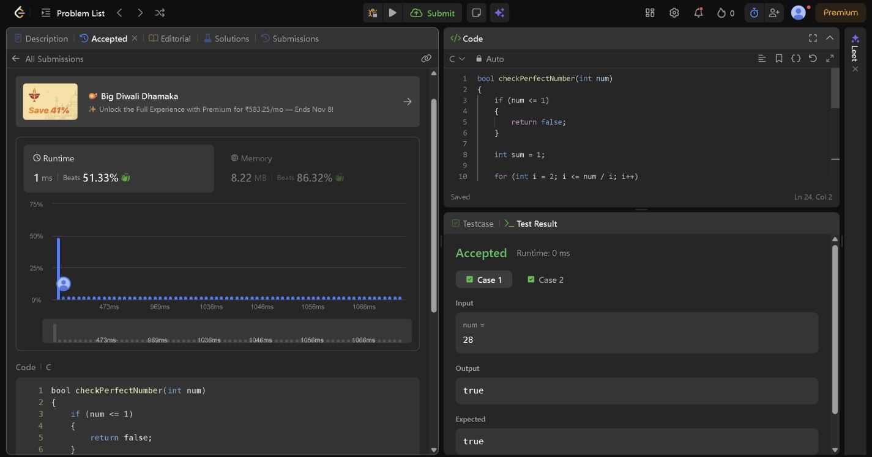

Module 6 — Nested loops: online judge problems

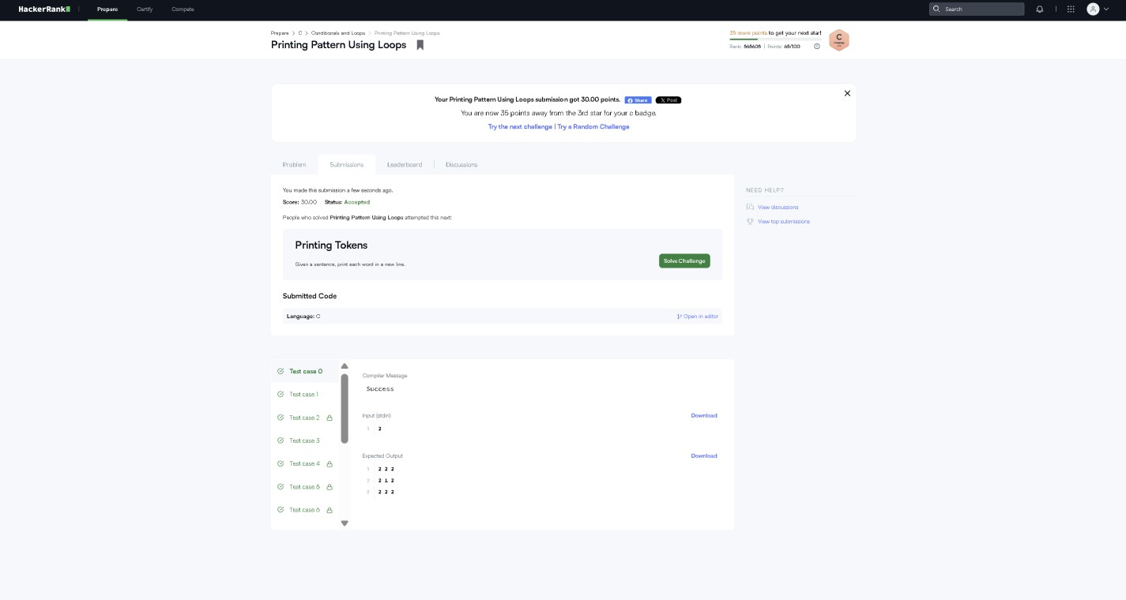

Module 7 — Nested-loop and pattern-printing questions

Question 1 — Print a Solid Square
Difficulty: Very Easy
Problem statement: Given a positive integer n, print a square containing n rows and n columns of asterisks (*). Do not print spaces between asterisks.
Input format: One integer n (1 ≤ n ≤ 20).
Output format: Print n lines, each containing exactly n asterisks.
Sample Input 4 | Sample Output  ****  ****  ****  ****
Hint: Use one loop for rows and one loop for columns.
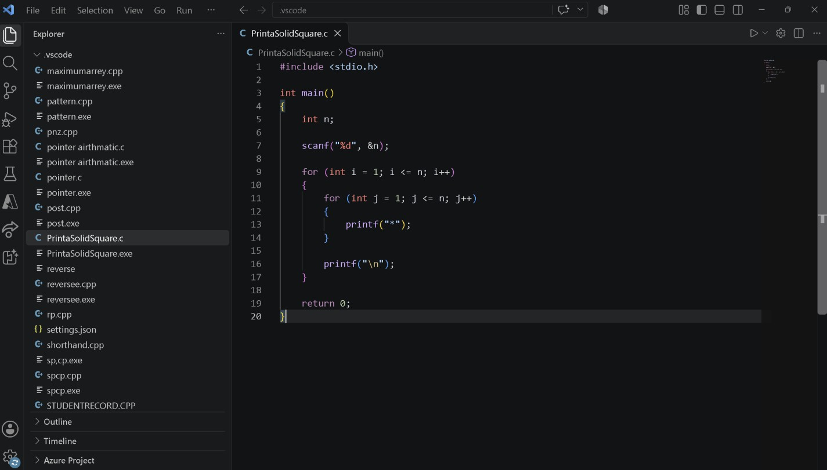

Question 2 — Print a Right-Angled Triangle
Difficulty: Very Easy
Problem statement: Given n, print a left-aligned triangle. Row i must contain exactly i asterisks, for i from 1 to n.
Input format: One integer n (1 ≤ n ≤ 20).
Output format: Print n lines. Line i contains i asterisks.
Sample Input 4 | Sample Output  *  **  ***  ****
Hint: The inner loop limit depends on the current row.

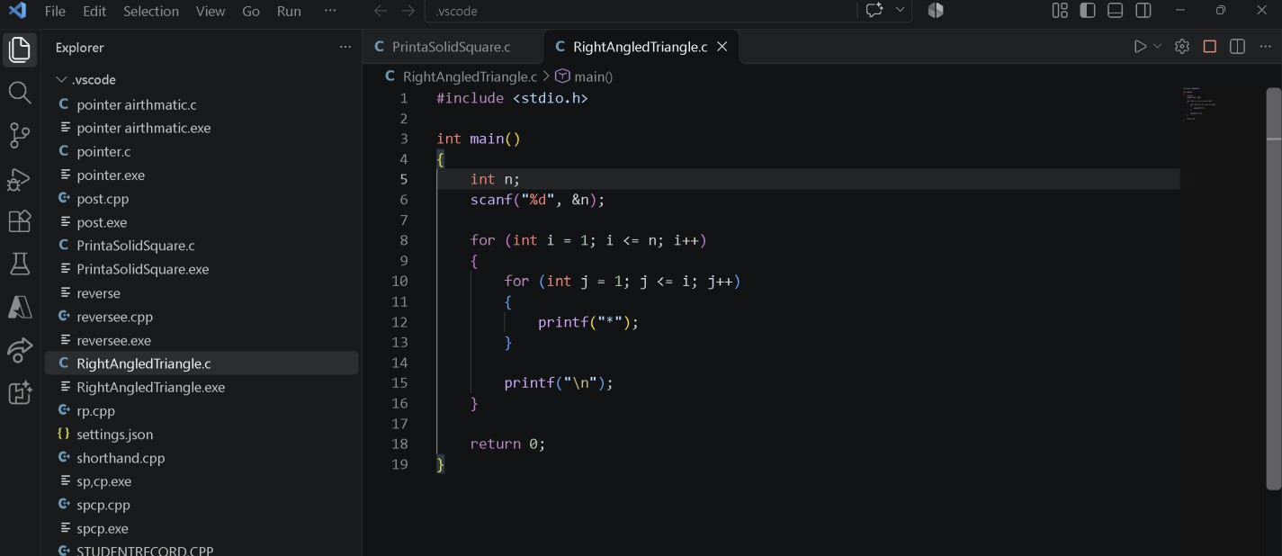

Question 3 — Print an Inverted Triangle
Difficulty: Easy
Problem statement: Given n, print a left-aligned inverted triangle. The first row contains n asterisks; each following row contains one fewer.
Input format: One integer n (1 ≤ n ≤ 20).
Output format: Print n lines, with the number of asterisks decreasing from n to 1.
Sample Input 4 | Sample Output  ****  ***  **  *
Hint: For row i, print n - i + 1 asterisks.
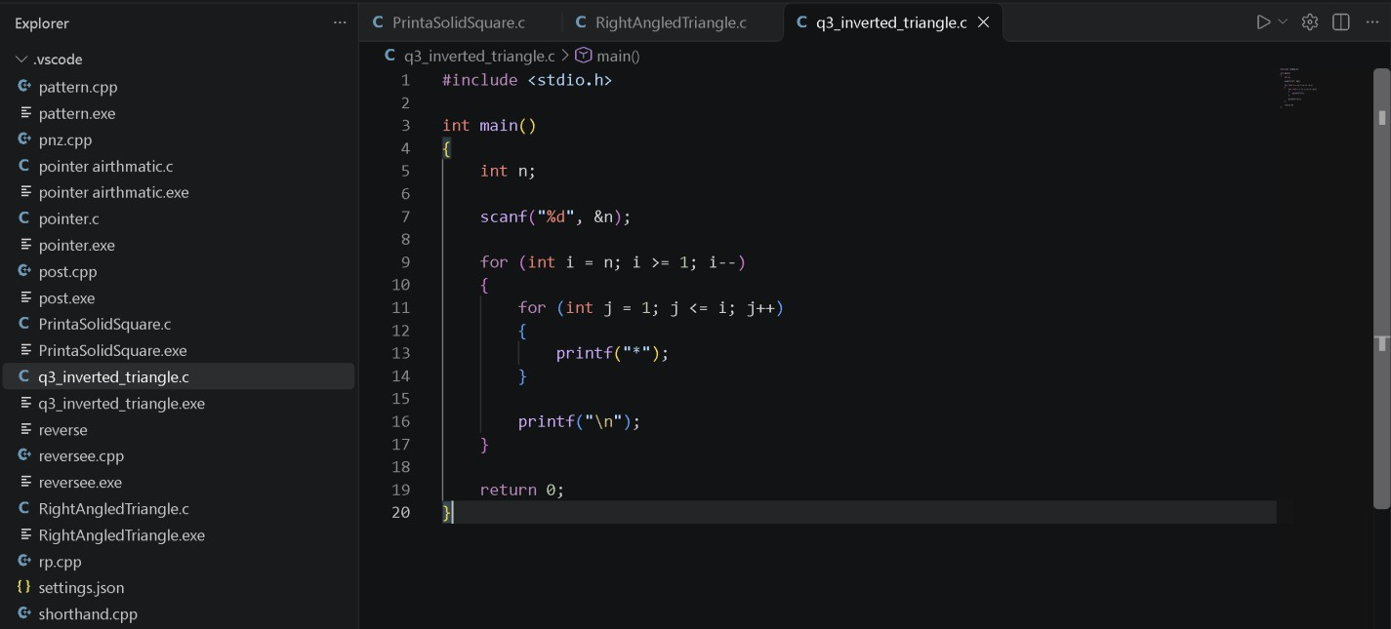

Question 4 — Print a Number Triangle
Difficulty: Easy
Problem statement: Given n, print n rows. On row i, print integers from 1 through i, separated by one space.
Input format: One integer n (1 ≤ n ≤ 20).
Output format: Print n lines with numbers separated by one space and no trailing spaces.

Sample Input 4 | Sample Output  1  1 2  1 2 3  1 2 3 4
Hint: The inner loop prints from 1 through the current row number.
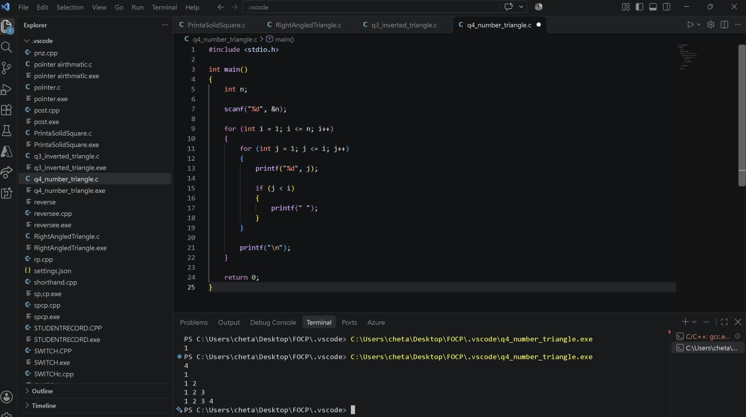

Question 5 — Print a Repeated-Number Triangle
Difficulty: Easy
Problem statement: Given n, print n rows. On row i, print the number i exactly i times, separated by one space.
Input format: One integer n (1 ≤ n ≤ 20).
Output format: Print n lines; row i contains i copies of i.
Sample Input 4 | Sample Output  1  2 2  3 3 3  4 4 4 4
Hint: Print the row counter during each inner-loop iteration.
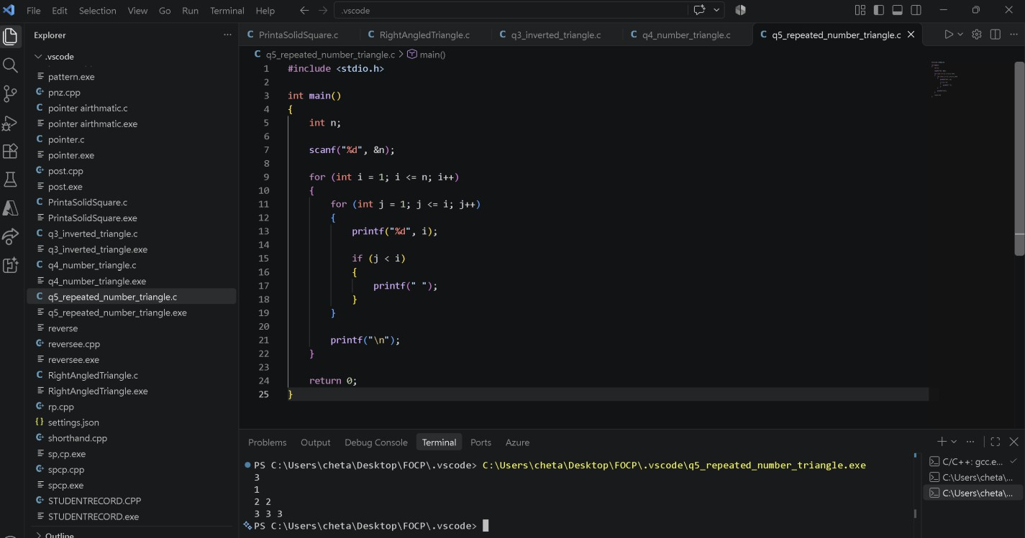

Question 6 — Print a Consecutive-Number Triangle
Difficulty: Easy
Problem statement: Print consecutive positive integers across triangular rows. Row 1 has one number, row 2 has two, and so on. Counting starts at 1 and continues across rows.
Input format: One integer n (1 ≤ n ≤ 20).
Output format: Print n lines, with values separated by one space.
Sample Input 4 | Sample Output  1  2 3  4 5 6  7 8 9 10
Hint: Maintain one counter that increases after each printed number.

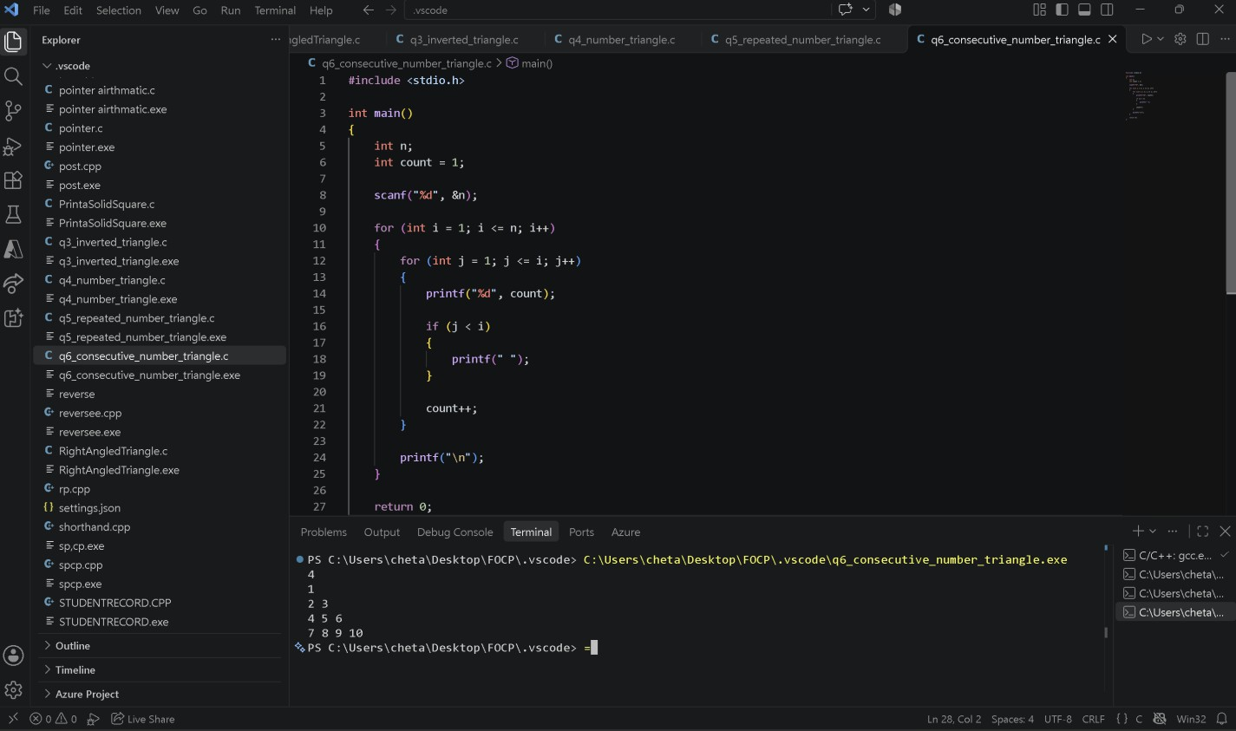

Question 7 — Print a Right-Aligned Star Triangle
Difficulty: Easy
Problem statement: Given n, print a right-aligned triangle. Row 1 has one asterisk and row n has n asterisks. Use leading spaces to align the right edges.
Input format: One integer n (1 ≤ n ≤ 20).
Output format: Print n lines. Leading spaces are required; do not add trailing spaces.
Sample Input 4 | Sample Output  *  **  ***  ****
Hint: Row i has n - i leading spaces and i asterisks.

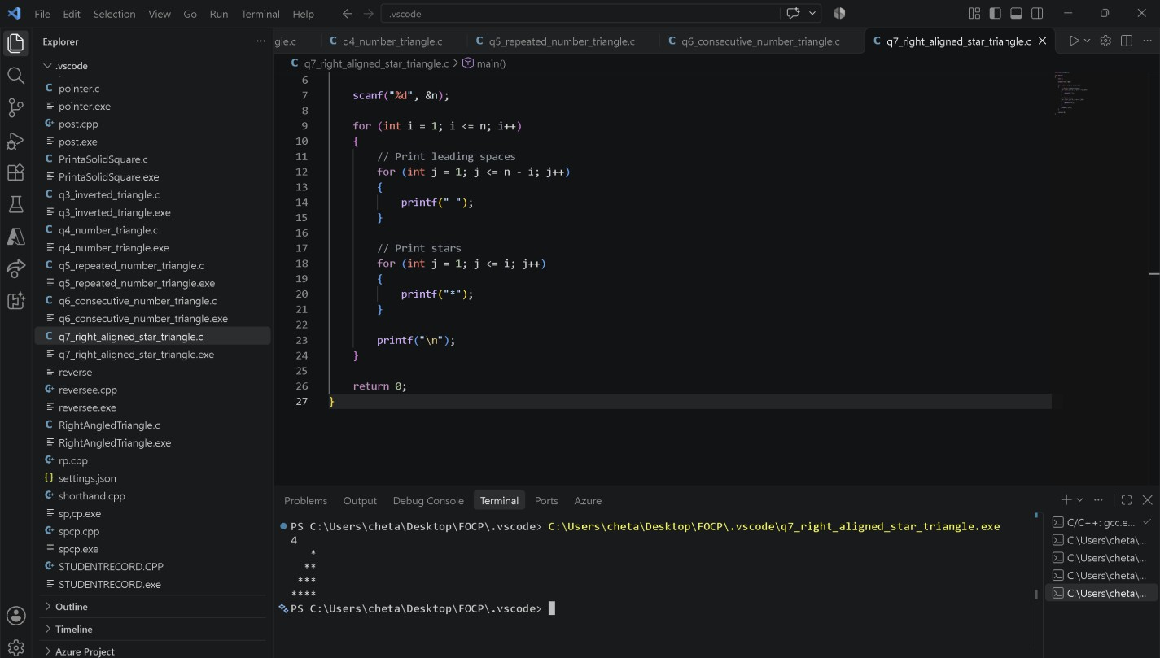

Question 8 — Print a Centered Pyramid
Difficulty: Easy–Moderate
Problem statement: Given n, print a centered pyramid with n rows. Row i contains 2i - 1 asterisks, preceded by enough spaces to center it.
Input format: One integer n (1 ≤ n ≤ 20).
Output format: Print n lines of leading spaces followed by an odd number of asterisks.
Sample Input 4 | Sample Output  *  ***  *****  *******
Hint: For row i, print n - i spaces and then 2*i - 1 asterisks.

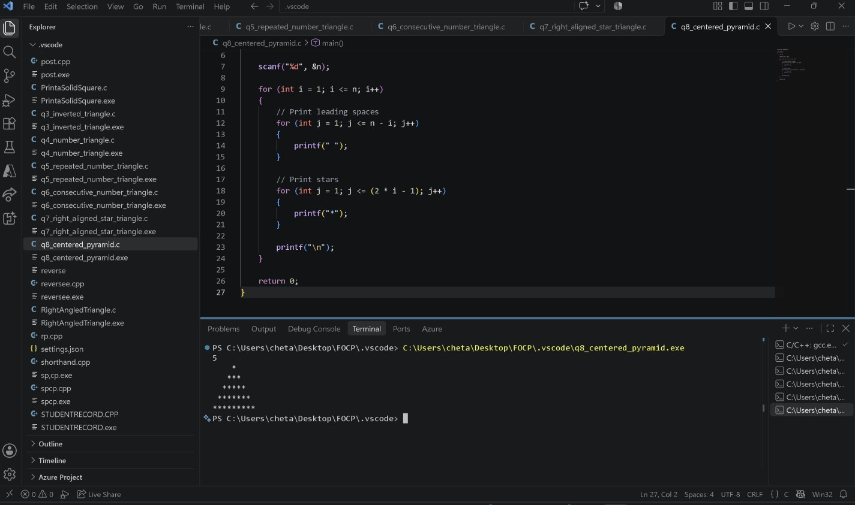

Question 9 — Print an Inverted Centered Pyramid
Difficulty: Easy–Moderate
Problem statement: Given n, print an inverted centered pyramid. The first row contains 2n - 1 asterisks; each next row has two fewer and one more leading space.
Input format: One integer n (1 ≤ n ≤ 20).
Output format: Print n lines, with the pyramid narrowing toward the bottom.
Sample Input 4 | Sample Output  *******  *****  ***  *
Hint: For row i, print i - 1 spaces and 2*(n - i) + 1 asterisks.

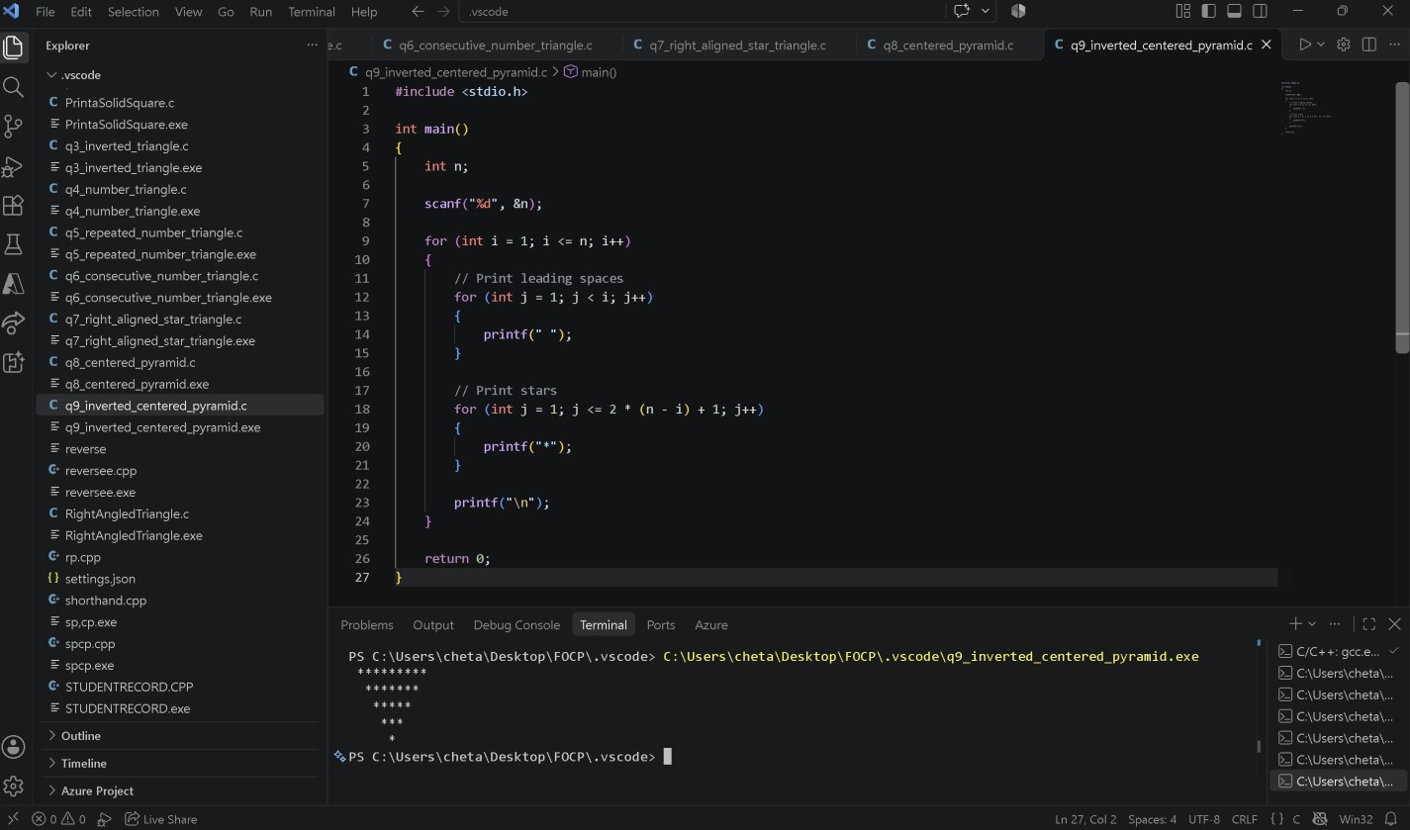

Question 10 — Print a Hollow Square
Difficulty: Moderate
Problem statement: Given n, print an n-by-n hollow square. Print an asterisk on the first row, last row, first column, or last column. Print a space inside.
Input format: One integer n (1 ≤ n ≤ 20).
Output format: Print n lines of width n; interior positions are spaces.
Sample Input 5 | Sample Output  *****  * *  * *  * *  *****
Hint: Print '*' when the row or column is on a boundary; otherwise print a space.
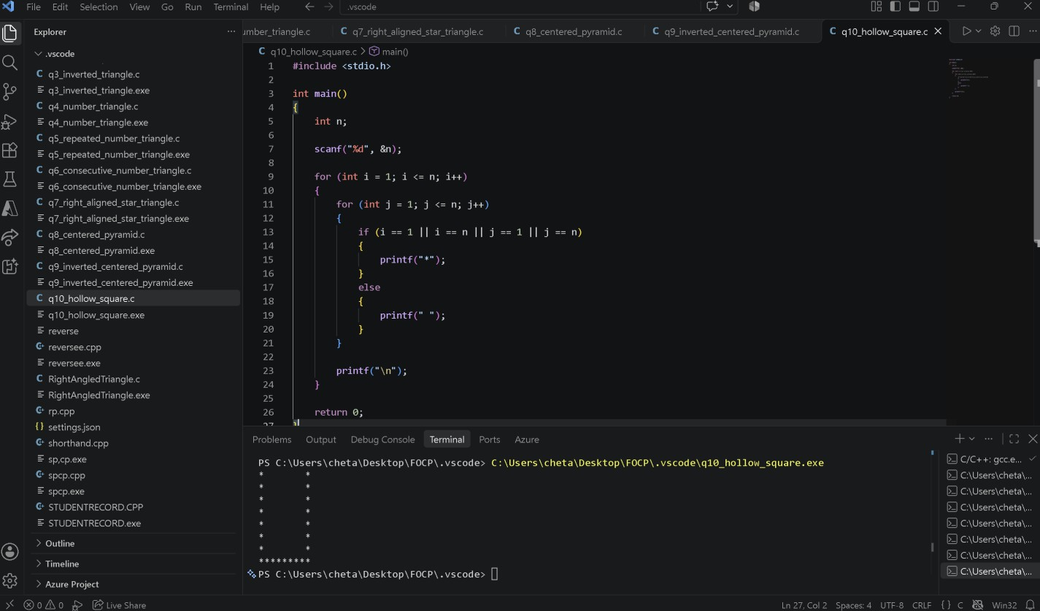

Question 11 — Print a Hollow Right-Angled Triangle
Difficulty: Moderate
Problem statement: Given n, print the outline of a left-aligned right-angled triangle. Print asterisks in the first column, on the diagonal boundary, and across the final row. Print spaces inside.
Input format: One integer n (1 ≤ n ≤ 20).
Output format: Print n lines. Preserve interior spaces; the final row contains n asterisks.

Sample Input 5 | Sample Output  *  **  * *  * *  *****
Hint: A position is on the outline if it is in the first column, on the diagonal, or in the final row.

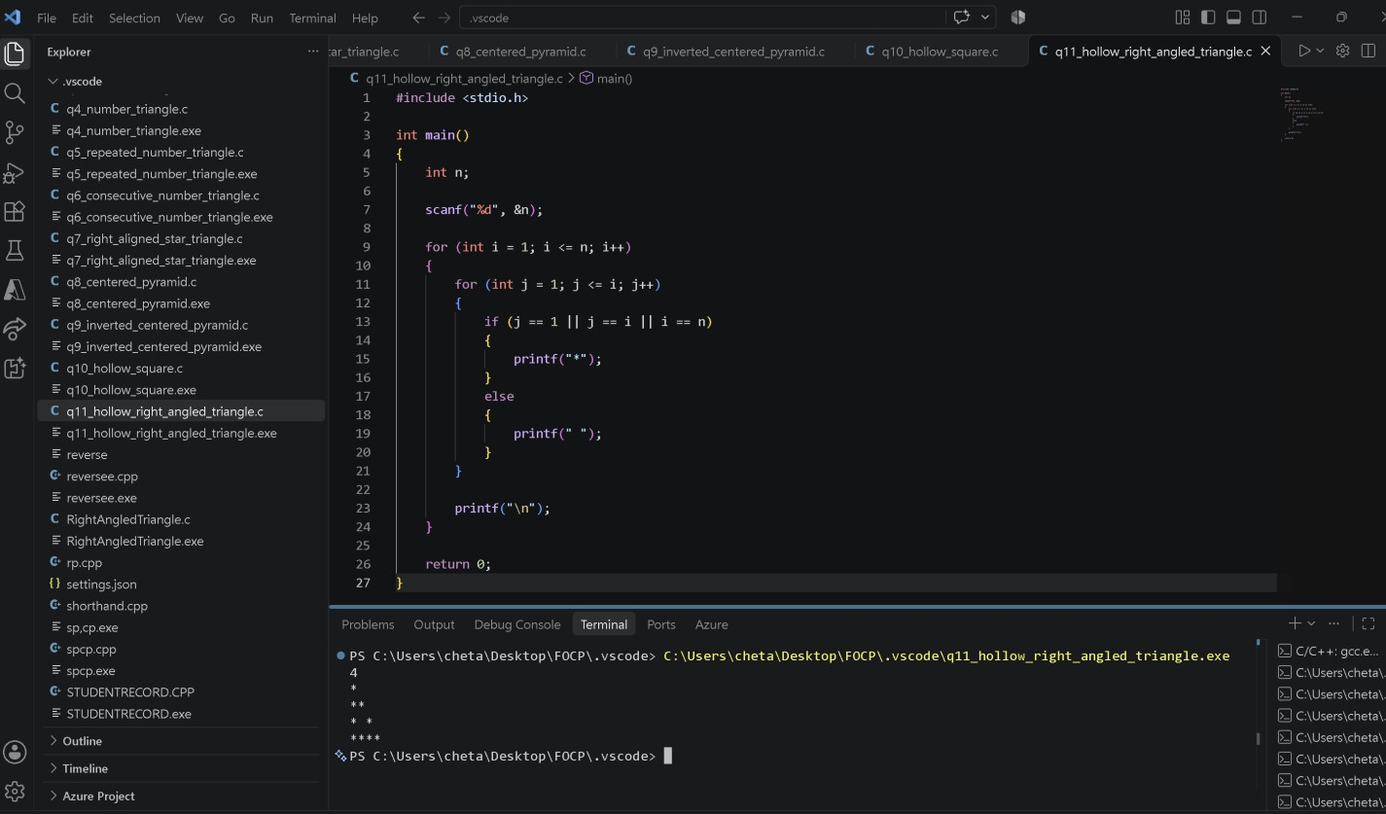

Question 12 — Print a Multiplication Table Grid
Difficulty: Moderate
Problem statement: Given n, print an n-by-n multiplication grid. At row i and column j, print i multiplied by j. Separate values with one space.
Input format: One integer n (1 ≤ n ≤ 12).
Output format: Print n lines, each containing n products separated by one space.
Sample Input 3 | Sample Output  1 2 3  2 4 6  3 6 9
Hint: The value at each position is the row number multiplied by the column number.

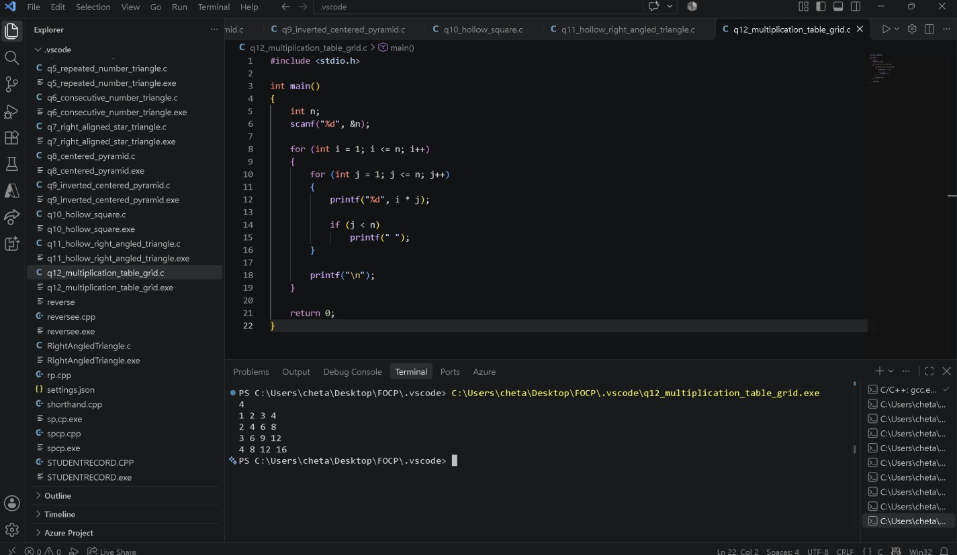

Question 13 — Print a Checkerboard
Difficulty: Moderate
Problem statement: Given n, print an n-by-n checkerboard using X and O. The top-left character must be X; adjacent horizontal and vertical cells alternate.
Input format: One integer n (1 ≤ n ≤ 20).
Output format: Print n lines of n characters, without spaces between characters.
Sample Input 4 | Sample Output  XOXO OXOX XOXO OXOX
Hint: Use whether the sum of the row and column indices is even or odd.

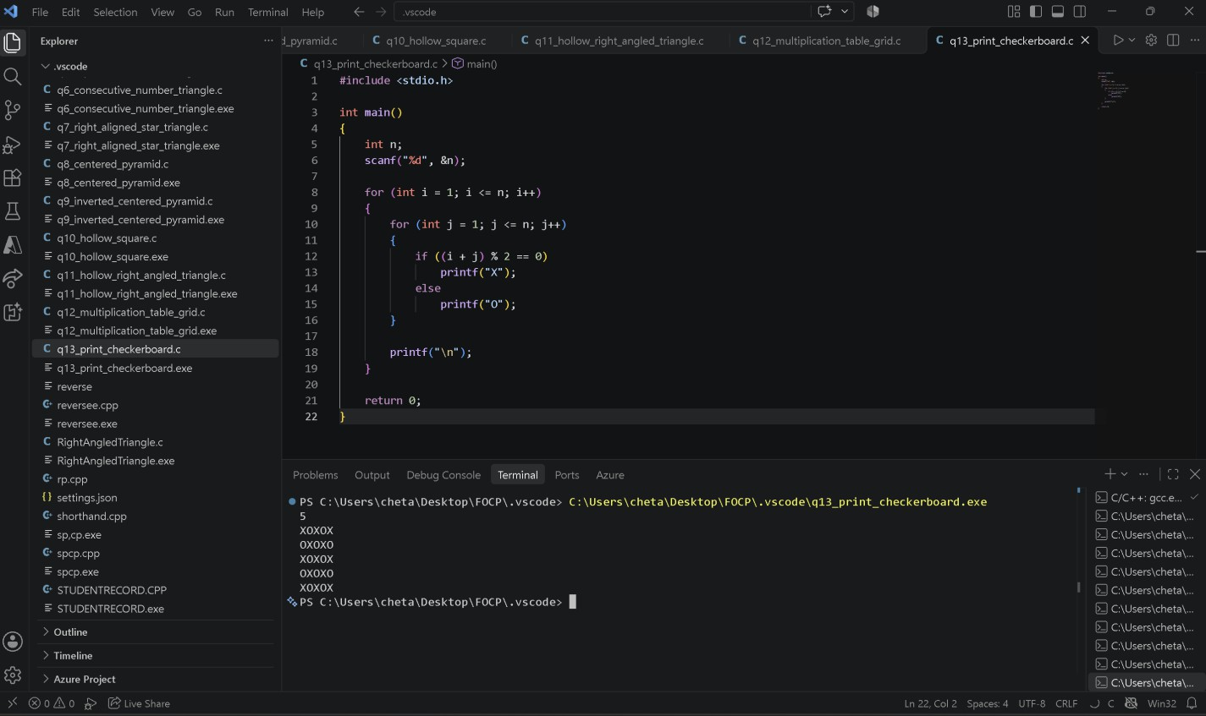

Question 14 — Print Floyd's Triangle
Difficulty: Easy–Moderate
Problem statement: Given n, print Floyd's triangle with n rows. Fill it with consecutive positive integers starting at 1, placing one number on row 1, two on row 2, and so on.
Input format: One integer n (1 ≤ n ≤ 20).
Output format: Print n lines with numbers separated by one space.
Sample Input 4 | Sample Output  1  2 3  4 5 6  7 8 9 10
Hint: Use a counter that continues increasing across rows.
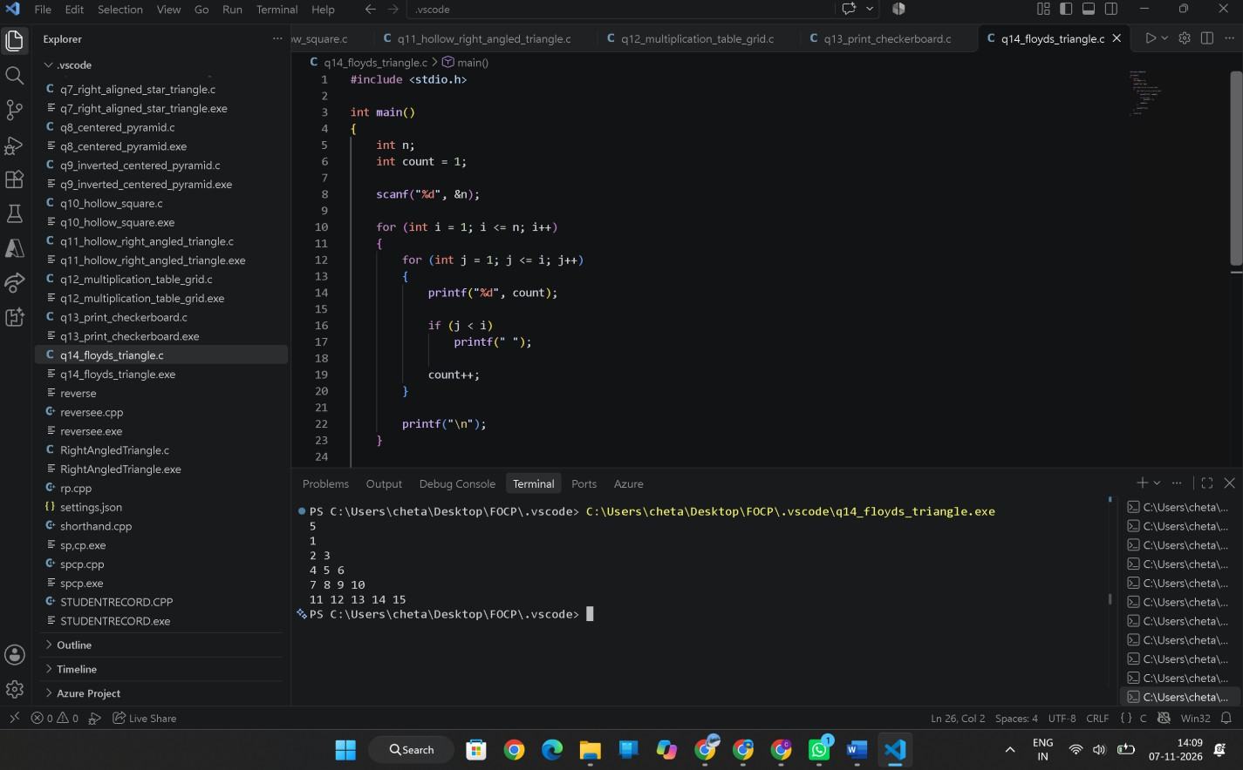

Question 15 — Print a Butterfly Pattern
Difficulty: Moderate
Problem statement: Given an odd integer n, print a butterfly made of asterisks. The top half widens row by row and the lower half mirrors it. Use spaces between the left and right wings.
Input format: One odd integer n (3 ≤ n ≤ 19).
Output format: Print n lines. Each line contains left and right wings with a central gap.
Sample Input 5 | Sample Output *  *  ** **  *** ***  ** **  * *
Hint: Build the upper half with increasing wing sizes, then mirror it.

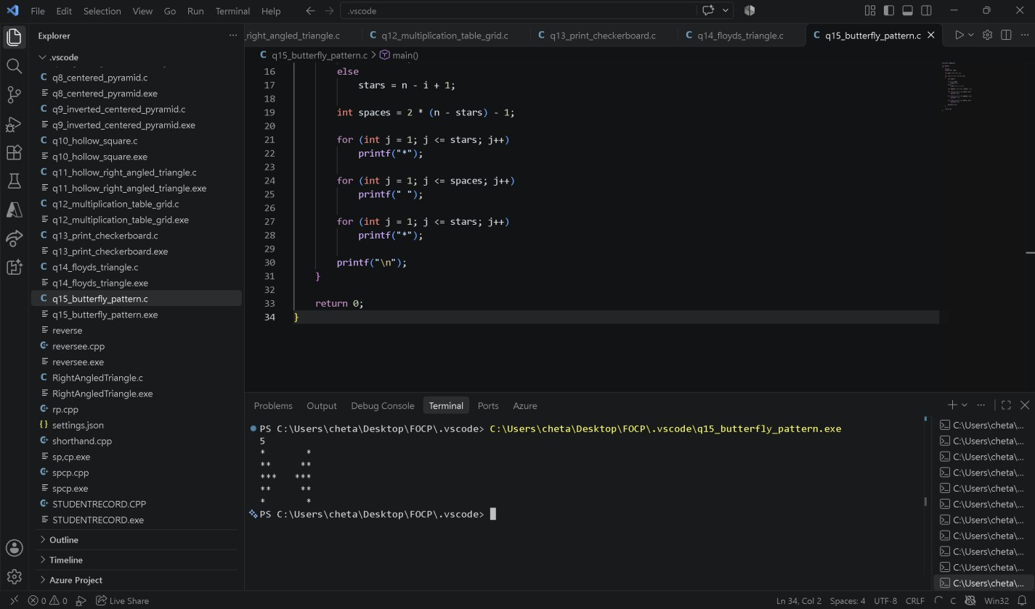

Question 16 — Print a Diamond Pattern
Difficulty: Moderate
Problem statement: Given n, print a centered diamond. The upper half has n rows including the widest row; then print n - 1 rows in decreasing width.
Input format: One integer n (1 ≤ n ≤ 10), representing the number of rows in the upper half.
Output format: Print 2n - 1 centered lines.
Sample Input 3 | Sample Output  *  ***  *****  ***  *
Hint: Print an increasing pyramid, then a decreasing half without repeating the widest row.


